Ad_Click_Fraud_Detection_Using_Machine_Learning_and_Deep_Learning_Algorithm

CONTENT
Abstract
1.INTRODUCTION
1.1 Motivation
1.2 Problem Statement
1.3 Objective of the Project
1.4 Scope
1.5 Project Introduction
2.LITERATURE SURVEY
2.1 Related Work
3. SYSTEM ANALYSIS
3.1 Existing System
3.2 Disadvantages
3.3 Proposed System
3.4 Advantages
3.5 work Flow of Proposed system
4. REQUIREMENT ANALYSIS
4.1 Function and non-functional requirements
4.2 Hardware Requirements
4.3 Software Requirements
4.4 Architecture
5. METHODOLOGY
6. SYSTEM DESIGN
6.1 Introduction of Input design
6.2 UML Diagram (class, use case, sequence, collaborative, deployment, activity, ER diagram and Component diagram)
6.3 Data Flow Diagram
7. IMPLEMENTATION AND RESULTS
7.1 Modules
7.2 Output Screens
8.SYSTEM STUDY AND TESTING
9.1 Feasibility study
9.2 Types of test & Test Cases
10. CONCLUSION
11. FUTURE ENHANCEMENT
12. REFERENCES

ABSTRACT
With the exponential growth of mobile advertising, fraudulent ad clicks have become a major concern, leading to substantial financial losses for advertisers. This project, Ad Click Fraud Detection Using Machine Learning and Deep Learning Algorithms, aims to develop an intelligent and scalable detection system capable of distinguishing between genuine and fraudulent clicks. The dataset contains crucial features such as IP address, application ID, device type, operating system version, publisher channel ID, click timestamp, and attribution time (if the app was downloaded post-click). The target variable is_attributed indicates whether a click led to an actual app download.
A wide range of models were implemented, including traditional Machine Learning algorithms like Logistic Regression, Decision Tree, Random Forest, K-Nearest Neighbors, Naive Bayes, SVM, Gradient Boosting, LightGBM, and XGBoost. Additionally, Deep Learning architectures such as Artificial Neural Networks (ANN), Convolutional Neural Networks (CNN), Deep Neural Networks (DNN), Recurrent Neural Networks (RNN), Long Short-Term Memory (LSTM), and Gated Recurrent Unit (GRU) were explored. A Stacking Classifier was used to combine model strengths and optimize performance. The backend integrates all models to compare results, while the Flask-based frontend allows users to input click features and receive real-time fraud detection outputs.
Keywords: Ad Click Fraud, Machine Learning, Deep Learning, Flask App, Stacking Classifier, LSTM, XGBoost, Click Prediction, Mobile Advertising, Classification.

1. INTRODUCTION
1.1 OBJECTIVE OF PROJECT:
The main objective of this project is to build an efficient and intelligent system capable of detecting fraudulent ad clicks in real time. By analyzing various features such as IP address, app ID, device type, OS version, channel ID, click time, and attribution status, the goal is to classify whether a click is genuine or potentially fraudulent. This system utilizes a range of Machine Learning and Deep Learning models—including Logistic Regression, Random Forest, XGBoost, CNN, LSTM, and more—to ensure high accuracy and generalization. The model performance is compared, and the best-performing models are integrated into a user-friendly Flask web application. This enables users to input features manually and receive instant predictions on click legitimacy.

1.2 PROBLEM STATEMENT:
In digital advertising, especially on mobile platforms, click fraud has emerged as a significant challenge. Fraudulent clicks—generated by bots or deceptive users—result in wasted advertising budgets, reduced ROI, and skewed analytics. Existing detection systems are often rule-based, static, or unable to generalize across diverse data. The problem addressed in this project is how to build a data-driven, intelligent, and adaptive system that can accurately classify ad clicks as fraudulent or genuine based on user behavior and device metadata. The solution must be scalable, robust, and deployable in real-time environments. The project seeks to use a variety of ML/DL models and compare their effectiveness in solving this issue while offering a deployable interface via a Flask web application.

1.3 MOTIVATION:
Click fraud is a growing issue in the mobile advertising industry, where fraudulent actors simulate fake clicks to earn revenue unfairly. This not only impacts advertisers financially but also skews campaign performance metrics and undermines trust in digital marketing platforms. The motivation behind this project is to create a reliable system that helps advertisers and marketers detect fraudulent clicks accurately, thereby preventing unnecessary ad spend and improving campaign efficiency. By leveraging both machine learning and deep learning models, and deploying the solution with an easy-to-use interface, the project aims to bridge the gap between complex predictive analytics and practical usage. It empowers stakeholders with technology to mitigate digital ad fraud in an effective, automated manner
1.4 SCOPE:
This project addresses the issue of click fraud in mobile advertising, focusing on the detection of fraudulent clicks before app attribution. It supports analysis and prediction using a combination of traditional ML models (e.g., Logistic Regression, Random Forest, XGBoost) and advanced deep learning architectures (e.g., CNN, LSTM, GRU). The solution includes backend training, evaluation of multiple models, and frontend deployment using Flask. The scope extends to model comparison, real-time fraud prediction, and system deployment in real-world advertising platforms. Future extensions may involve auto-updating models with live data, scaling for large-volume detection, and integration with ad networks or APIs to automate fraud prevention mechanisms efficiently.

1.5 PROJECT INTRODUCTION:
In today’s digital ecosystem, mobile advertising plays a crucial role in reaching targeted audiences efficiently. With the increasing shift toward app-based promotions and pay-per-click models, advertisers rely heavily on the accuracy and legitimacy of user interactions, especially ad clicks. However, the rise of click fraud—where bots or malicious users generate fake clicks—has become a significant threat. These fraudulent activities not only waste advertising budgets but also distort campaign performance metrics, leading to poor strategic decisions and reduced return on investment (ROI).
To address this growing issue, our project titled “Ad Click Fraud Detection Using Machine Learning and Deep Learning Algorithms” aims to build an intelligent fraud detection system that can automatically classify ad clicks as either genuine or fraudulent. The system leverages a dataset containing key features such as IP address, app ID, device type, operating system version, channel ID, click timestamp, attributed download time, and a target label is_attributed which indicates whether a click resulted in a legitimate app download.
A wide range of algorithms is employed to ensure robustness and accuracy. Classical machine learning models like Logistic Regression, Decision Tree, Random Forest, K-Nearest Neighbors, Naive Bayes, SVM, Gradient Boosting, LightGBM, and XGBoost are implemented. In parallel, deep learning techniques such as Artificial Neural Networks (ANN), Convolutional Neural Networks (CNN), Recurrent Neural Networks (RNN), Long Short-Term Memory (LSTM), Gated Recurrent Unit (GRU), and Deep Neural Networks (DNN) are trained to capture hidden patterns and sequential behaviors in the data.
To further enhance predictive performance, a Stacking Classifier is applied, which combines the strengths of multiple models and produces a meta-classifier capable of improved generalization. Each model's performance is evaluated using metrics such as accuracy, precision, recall, F1-score, and ROC-AUC. The best-performing models are selected for integration.
The backend system manages data preprocessing, model training, and predictions, while the Flask web application serves as the frontend. Users can input ad click features via the interface and receive immediate feedback on whether the click is likely to be fraudulent. This end-to-end solution not only supports data-driven fraud detection but also offers real-time deployment capabilities suitable for integration with live ad networks and fraud prevention systems.

2. LITERATURE SURVEY
2.1 Related work:
[1] Amreen Batool, Yungcheol Byun, An Ensemble Architecture Based on Deep Learning Model for Click Fraud Detection in Pay-Per-Click Advertisement Campaign, IEEE Access, 2022. DOI: 10.1109/ACCESS.2022.3211528. The paper introduces a hybrid deep learning model combining CNN and BiLSTM for feature extraction, with a Random Forest classifier. This ensemble model improved fraud detection performance in pay-per-click ad campaigns by leveraging both spatial and temporal features.
[2] Malak Aljabri, Rami Mustafa A. Mohammad, Click Fraud Detection for Online Advertising Using Machine Learning, Egyptian Informatics Journal, 2023. DOI: 10.1016/j.eij.2023.05.006. This study compares various ML models such as Random Forest, LightGBM, XGBoost, and MLP for detecting click fraud, integrating LIME for explainability. Random Forest achieved the highest performance (~95% accuracy), showing its robustness in imbalanced datasets.
[3] Archana Purwar, Arti Jain, Indu Chawla, Divansh Jain, Click Fraud Detection Using Ensemble Classifier, published in Advances in Artificial-Business Analytics and Quantum Machine Learning, 2024. The paper uses Recursive Feature Elimination (RFE) and an ensemble classifier based on Hellinger Distance Decision Trees (HDDT). The proposed model reached 99.72% accuracy on the TalkingData dataset, outperforming single classifiers.
[4] Benjamin Kirkwood, Mounika Vanamala, Naeem Seliya, Click Fraud Detection of Online Advertising Using Machine Learning Algorithms, IEEE International Conference on Electro Information Technology, 2024. Focuses on effective feature selection and tuning across multiple ML algorithms for fraud detection. The paper emphasizes the challenge of false positives and the need for robust models in dynamic advertising environments.
[5] Qixuan Yu, Xirui Tang, Feiyang Li, Zinan Cao, Improved Adaboost Algorithm for Web Advertisement Click Prediction Based on Long Short-Term Memory Networks, arXiv:2408.05245, 2024. URL: https://arxiv.org/abs/2408.05245. Combines LSTM with Adaboost for click prediction. The hybrid model achieves 92% accuracy, outperforming standard models by over 13%, particularly excelling in temporal data learning.
[6] Reem Alzahrani, Malak Aljabri, Rami Mustafa A. Mohammad, Ad Click Fraud Detection Using Machine Learning and Deep Learning Algorithms, IEEE Access, 2025. DOI: 10.1109/ACCESS.2025.3532200. This comprehensive study evaluates 9 ML/DL models (Decision Tree, XGBoost, ANN, CNN, RNN, etc.) on an ad fraud dataset. Using Recursive Feature Elimination, the Decision Tree and Random Forest achieved >98.99% accuracy, with the backend integrated into a real-time Flask application.

3. SYSTEM ANALYSIS
3.1 Existing System
The existing systems for ad click fraud detection rely on traditional Machine Learning and basic Deep Learning algorithms. Models like Logistic Regression, Decision Tree, Random Forest, K-Nearest Neighbors (KNN), Naive Bayes, and Support Vector Machine (SVM) are commonly used due to their simplicity and interpretability. Additionally, advanced techniques such as Gradient Boosting (GB), LightGBM, and XGBoost offer improved accuracy through ensemble learning. In the realm of deep learning, Artificial Neural Networks (ANN), Convolutional Neural Networks (CNN), Deep Neural Networks (DNN), and Recurrent Neural Networks (RNN) have been explored to capture non-linear and sequential patterns.While these methods provide reasonable performance, they often operate independently and struggle with complex temporal dependencies or require high tuning efforts. Moreover, they are limited in real-time adaptability and robustness when deployed on dynamic, large-scale advertising platforms.

3.2 Disadvantages of the Existing System
- Inability to capture long-term temporal dependencies (especially in RNN).
- High risk of overfitting on imbalanced data.
- Lower accuracy when applied to noisy or high-dimensional features.
- Difficult to combine strengths of multiple models effectively.
- Lack of scalability and generalization for unseen fraud patterns.
- Limited real-time prediction capabilities in deployment environments.

3.3 Proposed System
To overcome the shortcomings of the existing models, the proposed system incorporates a hybrid approach using Stacking Classifier, LSTM, and GRU networks. The Stacking Classifier strategically combines multiple base learners (both ML and DL) to enhance generalization and predictive power through meta-learning. Simultaneously, Long Short-Term Memory (LSTM) and Gated Recurrent Unit (GRU) architectures are employed to learn sequential dependencies and capture time-based fraud patterns more effectively than standard RNNs. This combination ensures that both static features (like IP, device) and temporal features (like click time) are intelligently processed.The backend performs model training, cross-validation, and prediction generation, while a Flask-based frontend enables real-time fraud detection through user inputs. The proposed system thus ensures higher accuracy, robustness, and adaptability for detecting complex fraud behaviors in large-scale ad environments.

3.4 Advantages of the Proposed System
- Captures complex temporal behavior using LSTM and GRU.
- Improves overall prediction accuracy with stacked ensemble learning.
- Reduces overfitting through model diversity and regularization.
- Adapts well to evolving fraud patterns and large datasets.
- Supports real-time predictions via an intuitive web interface.
- Provides scalable and robust architecture suitable for deployment.

  - PROJECT FLOW

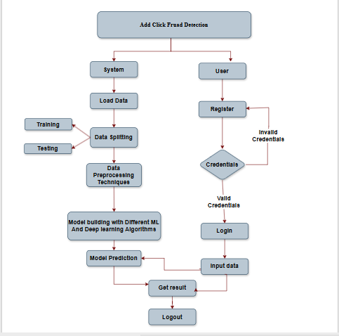

4. REQUIREMENT ANALYSIS
4.1 Function and non-functional requirements
Functional Requirements
The primary goal of the system is to detect fraudulent ad clicks in real time using a combination of machine learning and deep learning models. The core functionalities include:
- User Input Interface: Allow users (advertisers, analysts) to input click-related data such as IP address, device ID, app ID, click timestamp, channel, OS, and other metadata through a web-based form.
- Model Inference Engine: Automatically process the input data using trained models (e.g., XGBoost, Random Forest, LSTM, GRU) and classify each click as legitimate or fraudulent.
- Feature Preprocessing Module: Normalize and transform raw input into the correct format using preprocessing steps such as label encoding, timestamp transformation, and feature scaling.
- Prediction Output Display: Display the classification result along with a confidence score indicating the likelihood of fraud.
- Result Logging: Log each prediction request and its output (timestamp, user ID, input features, prediction label, model used, and confidence) for future audit, reporting, or retraining.
- Model Comparison Dashboard: Provide backend support to compare the performance (accuracy, F1-score, AUC) of all deployed models.
- User Authentication: Implement login functionality and role-based access (e.g., admin, analyst) to secure the system against unauthorized usage.
- Data Upload Utility: Support batch CSV file uploads for analyzing multiple clicks at once and provide downloadable reports.
- API Integration: Expose REST APIs for integration with advertising platforms or fraud monitoring tools.
Non-Functional Requirements
To ensure that the system meets industry-level performance, security, and user expectations, the following non-functional requirements are defined:
- Accuracy and Precision: The ensemble of ML and DL models must maintain a high accuracy (preferably > 95%) with strong precision and recall, especially to minimize false positives in fraud classification.
- Low Latency Inference: Predictions should be returned within 2–3 seconds for single-click input to support real-time fraud mitigation.
- Scalability: The backend must be capable of handling concurrent user sessions and batch predictions across large datasets without performance bottlenecks.
- Security and Compliance: All incoming data must be securely encrypted (HTTPS, AES) and stored per industry regulations (e.g., GDPR) with proper access controls.
- System Reliability: Ensure >99% uptime with proper failover and recovery mechanisms in case of service interruption or server failure.
- Usability and Responsiveness: The frontend, built using HTML, CSS, JavaScript, and Flask templates, should be responsive, mobile-friendly, and require minimal training.
- Auditability: Ensure that all predictions and data transactions are logged and traceable for audits or model revalidation.
- Maintainability: The Python-based backend code must follow modular design with clear documentation, enabling easy updates, model retraining, and debugging.
- Portability: The complete application must be containerized (e.g., Dockerized) to allow seamless deployment on local servers or cloud platforms (AWS, GCP, Azure).

4.2.1 SOFTWARE REQUIREMENS
Operating System : Windows 7/8/10
Server-side Script : HTML, CSS, Bootstrap & JS
Programming Language : Python
Libraries : Flask, Pandas, , Keras, Sklearn, Numpy , Seaborn
IDE/Workbench : VSCode
Server Deployment : Xampp Server
Database : MySQL

4.2.2 HARDWARE REQUIREMENTS
Processor - I3/Intel Processor
RAM - 8GB (min)
Hard Disk - 128 GB
Key Board - Standard Windows Keyboard
Mouse - Two or Three Button Mouse
Monitor - Any
4.3 ARCHITECTURE:
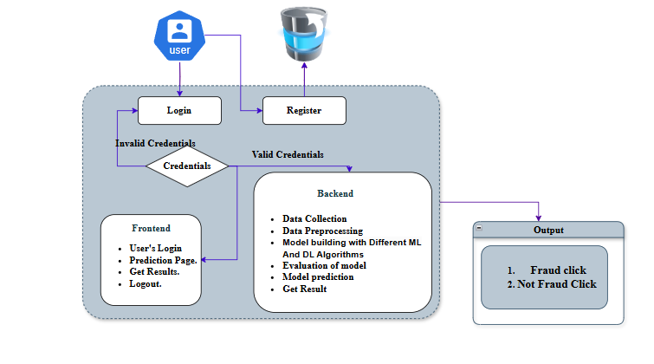
5.METHODOLOGIES

1. Logistic Regression (LR)
Logistic Regression is a binary classification algorithm that models the probability of a click being fraudulent using a sigmoid function. It assumes a linear relationship between the input features and the log-odds of the output class. It is fast, interpretable, and effective on linearly separable data. In this project, it serves both as a baseline classifier and as a meta-learner in the stacking ensemble. Logistic Regression outputs class probabilities, which can be used to rank risks, making it a simple yet effective tool for initial fraud detection tasks.
2. Decision Tree (DT)
Decision Trees split data into subsets using feature-based conditions. Each internal node represents a decision rule, and each leaf node represents a class label. It is easy to interpret, supports non-linear patterns, and handles both numerical and categorical data. In fraud detection, Decision Trees can capture decision boundaries based on feature thresholds like device type or click time. However, they are prone to overfitting, especially on noisy data. In this project, DT serves as both a standalone model and a base learner within the stacking classifier to provide fast and rule-based predictions.
3. Random Forest (RF)
Random Forest is an ensemble of Decision Trees built using bootstrap sampling and random feature selection. It reduces overfitting by averaging predictions from many uncorrelated trees, improving accuracy and generalization. In this project, it efficiently handles high-dimensional clickstream data and captures non-linear interactions between features like device type, IP, and click timestamp. It is robust to noisy data and imbalanced classes, making it a strong performer in fraud detection. Additionally, Random Forest provides feature importance scores, helping interpret which variables influence fraud detection the most.
4. K-Nearest Neighbors (KNN)
KNN is a lazy learning algorithm that classifies a new sample by finding the majority class among its k-nearest data points in the training set. It uses distance metrics like Euclidean distance for comparison. KNN is simple and effective on small datasets with distinct class boundaries. In fraud detection, it helps identify patterns based on feature proximity, such as IP or time-based clusters of clicks. However, it can be computationally expensive for large datasets and sensitive to irrelevant features and scaling. Its simplicity makes it suitable for comparison and baseline evaluation in this project.
5. Naive Bayes (NB)
Naive Bayes is a probabilistic classifier based on Bayes' theorem, assuming conditional independence between features. It computes the posterior probability of each class and selects the most likely one. Despite the independence assumption, it performs well on high-dimensional data and is computationally efficient. In this project, it’s applied to structured ad click data where rapid predictions are needed. Its simplicity and speed make it ideal for streaming data scenarios or as a lightweight model for comparison. Naive Bayes also works well with categorical and sparse features like app ID or OS version.
6. Support Vector Machine (SVM)
SVM is a margin-based classifier that finds the hyperplane that best separates two classes with maximum margin. It supports non-linear classification using kernel functions like RBF or polynomial kernels. SVM works well in high-dimensional spaces and is effective in fraud detection tasks where classes are separable. It can handle complex relationships among features like click sequence patterns or channel distributions. However, SVM can be slow on large datasets. In this project, it is used to benchmark performance against other models due to its solid theoretical foundation and ability to generalize well.
7. Gradient Boosting (GB)
Gradient Boosting is an ensemble method that builds models sequentially, where each new model corrects the residual errors of the previous ones. It uses gradient descent to minimize the loss function. In this project, GB captures complex relationships in clickstream data by combining many weak learners, typically decision trees. It offers high accuracy but is sensitive to overfitting and hyperparameter tuning. Gradient Boosting is effective in scenarios with class imbalance and can model subtle fraud patterns. Its interpretability and performance make it a strong choice for fraud detection in ad campaigns.
8. LightGBM
LightGBM is a fast, high-performance gradient boosting framework designed for large datasets. It uses histogram-based algorithms and grows trees leaf-wise rather than level-wise, improving accuracy and speed. In this project, LightGBM handles high-dimensional click data with ease, offering superior performance on large-scale ad fraud datasets. It supports parallel learning, native categorical features, and regularization techniques, making it efficient and scalable. LightGBM is used both as a standalone model and as a base learner in the stacking ensemble due to its robustness, speed, and effectiveness in fraud classification tasks.
9. XGBoost
XGBoost is an optimized gradient boosting algorithm known for its performance and scalability. It incorporates regularization (L1/L2), parallel processing, and missing value handling. In this project, XGBoost is one of the top-performing models, identifying fraudulent clicks by learning complex patterns in clickstream features. Its ability to handle noise, imbalanced data, and overfitting makes it suitable for real-world ad fraud scenarios. Additionally, XGBoost provides interpretable outputs through feature importance metrics. It is also used in the stacking ensemble for boosting overall accuracy and stability.
10. Artificial Neural Network (ANN)
ANNs are feedforward networks composed of input, hidden, and output layers, with each neuron applying a weighted sum followed by an activation function. They learn complex non-linear relationships in data. In this project, ANN is applied to model interactions between features like IP, device, app, and time. It provides better generalization than linear models but requires careful tuning and preprocessing. ANNs work well with structured data and can handle noise and variance. Their flexibility makes them a suitable choice for integrating multiple data features in fraud detection.
11. Convolutional Neural Network (CNN)
CNNs are designed for spatial data like images, but they can be applied to structured data by reshaping it into 2D grids. They use convolutional filters to extract local patterns and pooling layers to reduce dimensions. In this project, CNN is used to model spatial relationships between engineered features. It identifies complex interactions among variables like app ID, timestamp, and channel in a structured way. CNNs are highly effective in automatic feature extraction and generalization, making them valuable for fraud classification with minimal manual feature engineering.
12. Deep Neural Network (DNN)
DNNs extend ANNs by stacking multiple hidden layers, allowing for the learning of more abstract and complex feature hierarchies. In this project, DNN is used to capture intricate relationships within high-dimensional click data. It enables deeper representation learning and performs well on large datasets with many input features. Although DNNs are prone to overfitting, proper regularization and dropout techniques mitigate this. Their versatility and ability to learn non-linear functions make DNNs suitable for modeling the diverse patterns seen in fraudulent and legitimate clicks.
13. Recurrent Neural Network (RNN)
RNNs are designed to handle sequential data by maintaining hidden states that capture temporal dependencies. Each input is processed in a sequence, with output dependent on previous computations. In this project, RNN is used to model sequences of user click behaviors. RNNs are effective when fraud patterns depend on the order and timing of clicks. However, traditional RNNs suffer from vanishing gradient problems in long sequences. Despite this, they are useful for basic temporal modeling and serve as a foundation for more advanced models like LSTM and GRU.
14. Long Short-Term Memory (LSTM)
LSTM is a specialized RNN architecture that overcomes the limitations of traditional RNNs by introducing memory cells and gating mechanisms. It is capable of learning long-term dependencies and filtering irrelevant information. In this project, LSTM models user behavior over time, capturing sequences and timing of clicks to detect fraud patterns. LSTM helps identify coordinated or time-delayed fraudulent activities. It is well-suited for sequential fraud detection tasks where historical context significantly affects prediction outcomes.
15. Gated Recurrent Unit (GRU)
GRU is a simplified version of LSTM that combines the forget and input gates into a single update gate. It retains the ability to learn sequential dependencies with fewer parameters, resulting in faster training. In this project, GRU processes time-ordered click data, learning behavioral sequences indicative of fraud. It strikes a balance between complexity and performance, making it ideal for real-time systems where quick decision-making and temporal learning are crucial.
16. Stacking Classifier
A Stacking Classifier is an ensemble learning technique that combines predictions from multiple base models to improve accuracy. In this project, Decision Tree, Random Forest, LightGBM, and XGBoost serve as base learners, while Logistic Regression acts as the meta-learner. This approach leverages the strengths of diverse models, reducing overfitting and improving generalization. Stacking is particularly effective when individual models capture different data aspects. It boosts overall system reliability, especially in imbalanced and complex fraud detection scenarios.

6. SYSTEM DESIGN
6.1 Introduction of Input Design:
In the context of the Ad Click Fraud Detection System, input design refers to the process of determining the structure, format, and interface for collecting ad click-related data from users or uploaded files. These inputs serve as the foundation for performing fraud detection and must be accurately and efficiently captured to ensure reliable model predictions.
Proper input design ensures:
- Clear and consistent user interaction with the web interface.
- Accurate preprocessing and transformation of data before it is fed to the machine learning or deep learning models.
- Validation of fields such as IP address, app ID, timestamp, and channel ID to prevent garbage data from entering the system.
Key Inputs for the System
- IP address
- App ID
- Device type
- Operating System version
- Channel ID
- Click timestamp
- Attribution time (if applicable)
Input Design Objectives
- Design a web-based input form that is intuitive, easy to fill, and secure.
- Allow CSV file uploads for batch analysis of click data.
- Minimize the input effort by using dropdowns and auto-fill fields wherever applicable.
- Implement client-side and server-side validations for data integrity (e.g., valid timestamp, IP format).
- Create modular input handling logic that seamlessly integrates with model preprocessing pipelines.
6.2 Output Design:
The output design is critical for presenting the results of fraud prediction in a clear and actionable manner. It includes the classification result (fraudulent or genuine click), the model's confidence score, and additional metadata for decision-making.
In this project, output is generated by ML/DL models and must be displayed in a structured and user-friendly format, either in the UI or as downloadable reports.
Output Elements
- Classification label (Fraudulent / Genuine)
- Confidence score (e.g., 94.67%)
- Timestamp of prediction
- File name (if uploaded)
- Model used for prediction (e.g., XGBoost, LSTM)
Output Design Objectives
- Present the fraud detection result in real-time after submission.
- Ensure output is interpretable, especially when confidence scores are low.
- Route output to the appropriate user role (admin, analyst).
- Enable report download and audit logging for historical analysis.
- Prevent generation of unnecessary or redundant outputs.
6.2 UML Diagrams:
6.2.1 USE CASE DIAGRAM:
A use case diagram in the Unified Modeling Language (UML) is a type of behavioral diagram defined by and created from a Use-case analysis. Its purpose is to present a graphical overview of the functionality provided by a system in terms of actors, their goals (represented as use cases), and any dependencies between those use cases. The main purpose of a use case diagram is to show what system functions are performed for which actor. Roles of the actors in the system can be depicted.
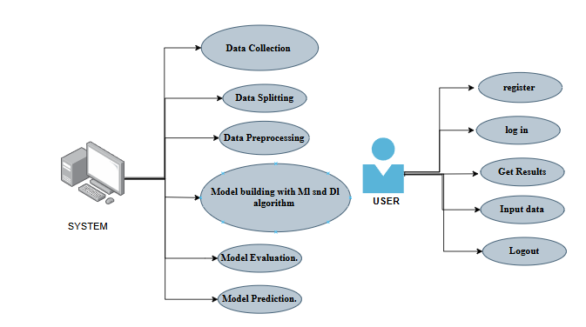

6.2.2 CLASS DIAGRAM:
In software engineering, a class diagram in the Unified Modeling Language (UML) is a type of static structure diagram that describes the structure of a system by showing the system's classes, their attributes, operations (or methods), and the relationships among the classes. It explains which class contains information.

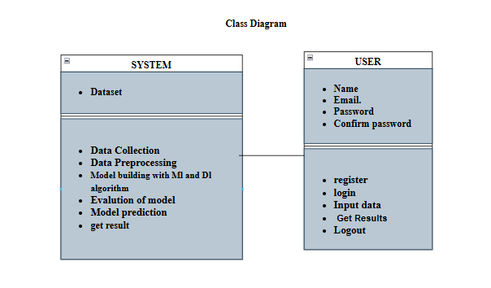
6.2.3 SEQUENCE DIAGRAM:
A sequence diagram in Unified Modeling Language (UML) is a kind of interaction diagram that shows how processes operate with one another and in what order. It is a construct of a Message Sequence Chart. Sequence diagrams are sometimes called event diagrams, event scenarios, and timing diagrams.
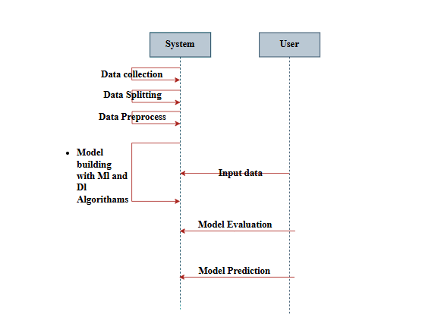
6.2.4 COLLABORATION DIAGRAM:
In collaboration diagram the method call sequence is indicated by some numbering technique as shown below. The number indicates how the methods are called one after another. We have taken the same order management system to describe the collaboration diagram. The method calls are similar to that of a sequence diagram. But the difference is that the sequence diagram does not describe the object organization whereas the collaboration diagram shows the object organization.
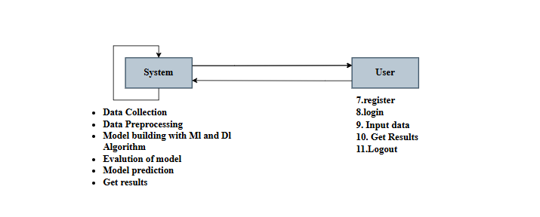

6.2.5 DEPLOYMENT DIAGRAM
Deployment diagram represents the deployment view of a system. It is related to the component diagram. Because the components are deployed using the deployment diagrams. A deployment diagram consists of nodes. Nodes are nothing but physical hardware’s used to deploy the application.
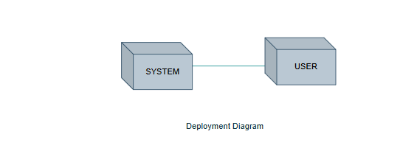
6.2.6 COMPONENT DIAGRAM:
A component diagram, also known as a UML component diagram, describes the organization and wiring of the physical components in a system. Component diagrams are often drawn to help model implementation details and double-check that every aspect of the system's required functions is covered by
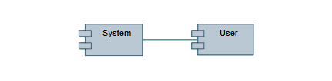
6.2.7 ACTIVITY DIAGRAM:
Activity diagrams are graphical representations of workflows of stepwise activities and actions with support for choice, iteration and concurrency. In the Unified Modeling Language, activity diagrams can be used to describe the business and operational step-by-step workflows of components in a system. An activity diagram shows the overall flow of control.
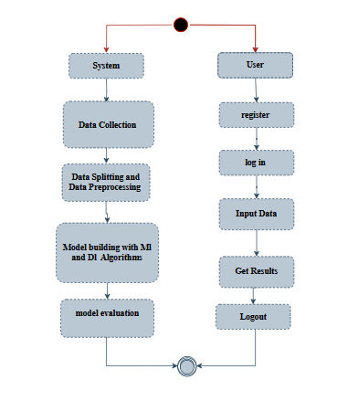
6.2.8 ER DIAGRAM
An Entity–relationship model (ER model) describes the structure of a database with the help of a diagram, which is known as Entity Relationship Diagram (ER Diagram).
An ER diagram shows the relationship among entity sets. An entity set is a group of similar entities and these entities can have attributes.
In terms of DBMS, an entity is a table or attribute of a table in database, so by showing relationship among tables and their attributes, ER diagram shows the complete logical structure of a database.

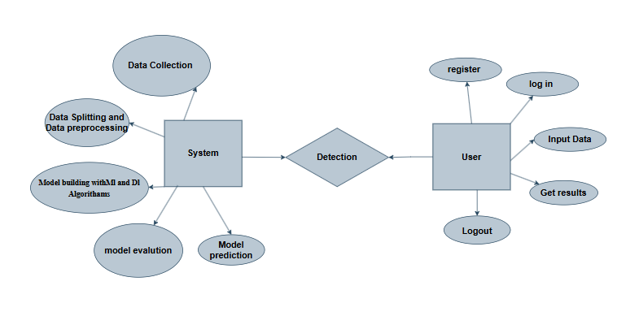
6.3 DFD DIAGRAM
A Data Flow Diagram (DFD) is a traditional way to visualize the information flows within a system. A neat and clear DFD can depict a good amount of the system requirements graphically. It can be manual, automated, or a combination of both. It shows how information enters and leaves the system, what changes the information and where information is stored. The purpose of a DFD is to show the scope and boundaries of a system as a whole. It may be used as a communications tool between a systems analyst and any person who plays a part in the system that acts as the starting point for redesigning a system.
DFD Level-1 Diagram:

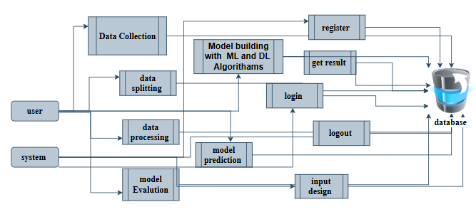
DFD Level-2 Diagram:
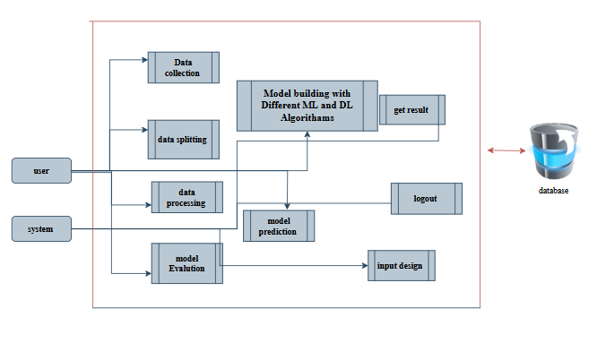

7. IMPLEMENTATION AND RESULTS
7.1 Modules
1. Data Collection:
This module is responsible for collecting ad click data from available datasets or live sources. The dataset includes essential features such as IP address, app ID, device type, OS version, channel ID, click time, and attribution time. The target variable indicates if the user downloaded the app post-click.
2.Data Preprocessing:
Raw data is often noisy or incomplete. This module handles missing values, encodes categorical variables, and scales numerical features. Timestamp fields like click_time are converted into meaningful features (hour, day, etc.) to improve model learning.
3.Splitting Data:
The dataset is split into training and testing sets to evaluate model generalization. Stratified splitting ensures class balance is maintained, which is especially important for imbalanced data like fraud detection.
4.Model Training:
Multiple models including Logistic Regression, Decision Tree, Random Forest, KNN, ANN, SVM, XGBoost, LightGBM, CNN, RNN, LSTM, GRU, and Stacking Classifier are trained on the prepared training dataset using appropriate hyperparameters.
5. Model Evaluation:
Each trained model is evaluated using metrics like accuracy, precision, recall, F1-score, and ROC-AUC. This module compares model performance to identify the best candidates for deployment.

- Model Prediction:
This module handles real-time predictions. It receives input features from users and applies the best-performing model(s) to predict whether a given ad click is fraudulent or legitimate.
👤 User Modules
1.Login Page:
Allows registered users to securely log into the system using their email and password. Session management ensures secure and authenticated access to other parts of the application.
2.Registration Page:
New users can create an account by filling in required details like name, email, and password. Upon successful registration, users are redirected to the login page.
3.Upload Page:
Users can upload new datasets for training or testing purposes. The uploaded file is validated for format and structure before being processed for modeling.
4.Model Page:
This page displays the performance of all trained models. Users can view evaluation as accuracy model for prediction tasks.
5.Prediction Page:
Provides an interface where users input features such as IP, app ID, device type, OS, channel, and click time. The model uses these inputs to predict whether the click is fraudulent or not and displays the result instantly.
6.Logout
To ensure data security and session integrity, the logout module allows users to safely end their session. When the logout option is selected, the system clears all active session data and redirects the user to the login page.
7.2 Output Screens:
INDEX PAGE: This is the index page of the project website.
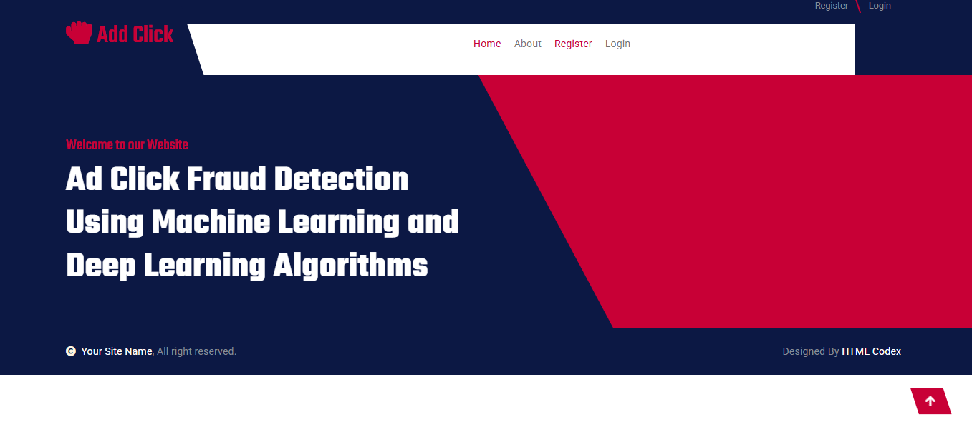REGISTRATION PAGE: In this page user can register with their credentials such as name, email, password.


LOGIN PAGE: In this page, user can login with their registered credentials.
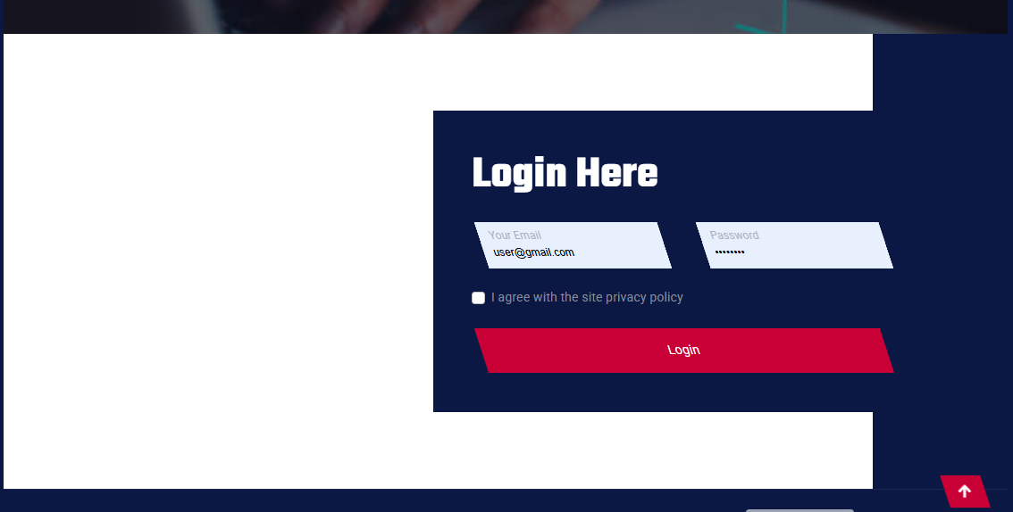

HOME PAGE: After successfully login, this page will be shown.

ABOUT PAGE: This page contains information about this website.

UPLOAD PAGE: It Will display dataset
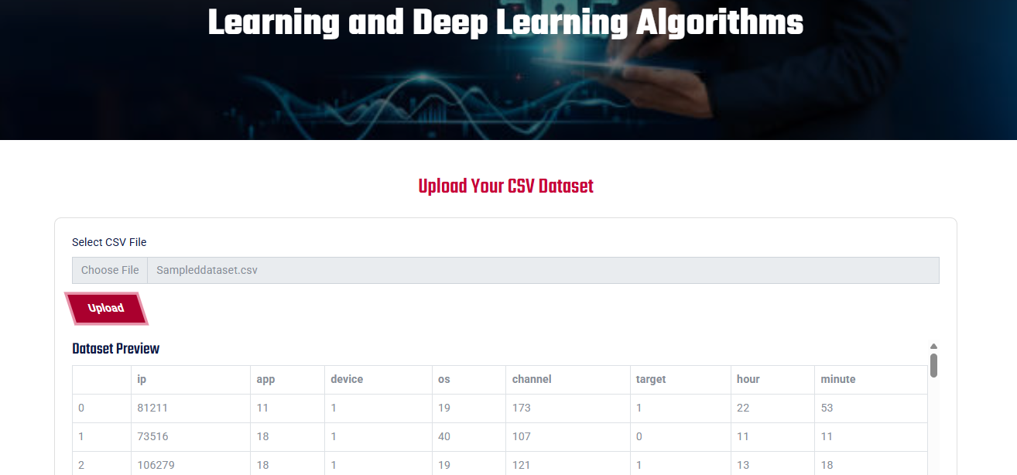

MODEL PAGE: It Will Show Accuracy of each models
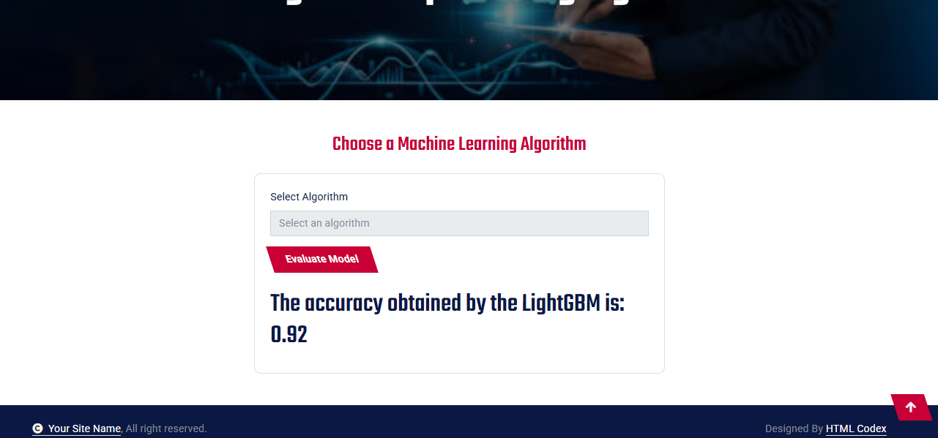
PREDICTION PAGE: In here user can give data and get prediction.
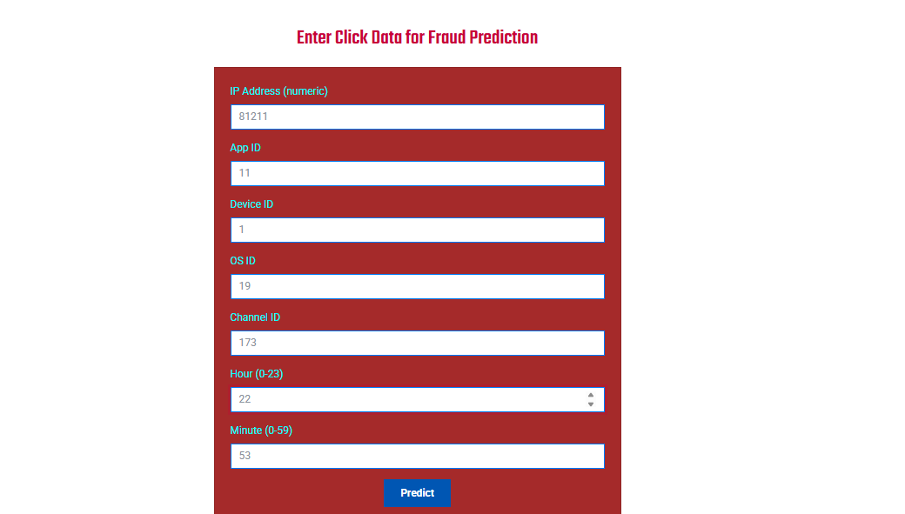

RESULT PAGE: In here, user result will be display.


8. SYSTEM STUDY AND TESTING
8.1 Feasibility Study
Before developing the Ad Click Fraud Detection System, a feasibility study was conducted to evaluate its practicality, cost-effectiveness, technical viability, and user acceptance. This assessment helps ensure that the system will not become a burden to organizations intending to use it for ad fraud prevention.
Economic Feasibility
This study evaluates whether the project is financially viable. The system was developed using open-source tools and frameworks such as Python, Flask, Scikit-learn, TensorFlow, and MySQL. This minimized development costs, as no commercial licenses were required. As a result, the solution is cost-effective and scalable for advertising platforms and small agencies without heavy investment.
Technical Feasibility
The system is technically feasible and does not require specialized hardware or high-end infrastructure. It can be deployed on standard servers or cloud platforms (like AWS, GCP). The backend is built using Python and Flask, with models trained using standard ML/DL libraries. Thus, implementation requires only modest computing resources and minimal reconfiguration.
Social Feasibility
The system is designed with a user-friendly web interface that allows analysts and advertisers to upload click data, receive predictions, and view reports. No prior technical expertise is needed. Users can easily understand the outputs, and appropriate documentation and guidance ensure acceptance and trust in the system. Constructive user feedback is encouraged and welcomed for future improvement.

System Testing
Testing is essential to ensure the system performs as expected and meets functional and user requirements. Various levels and types of tests were conducted throughout development to detect bugs, verify logic, and ensure system stability, usability, and accuracy.
8.2 Types of Tests
Unit Testing
Unit testing was carried out on individual components such as:
- Data preprocessing functions (e.g., encoding, normalization)
- Model loading and prediction modules
- Input validation logic in the Flask routes
Each function was tested with valid and edge case inputs to ensure it performs its role accurately. All internal logic paths were verified to produce correct outputs.
Integration Testing
Integration testing was performed to ensure smooth communication between the frontend, backend, model modules, and database components. For instance:
- Verifying that the uploaded data is correctly passed from the frontend to the backend
- Ensuring preprocessing and prediction pipelines work together
- Checking database logging of prediction history
All integrated components operated cohesively, validating the consistency of overall system functionality.
Functional Testing
Functional testing ensured that each feature of the system worked as specified:
- Valid and invalid data inputs were accepted or rejected as intended
- The system accurately classified ad clicks and displayed the correct result
- The prediction confidence score was displayed with every result
- Downloadable reports and user login features worked as expected
User Acceptance Testing (UAT)
UAT was conducted with a sample of end-users (marketing analysts, data scientists) to verify system usability and functionality from the user's perspective. All feedback was positive, and the system met the intended goals with no critical defects reported.
White Box Testing
White box testing was performed to validate the internal workings of backend logic, model pipelines, and API routes. This involved testing specific conditions in code paths and ensuring robustness of the logic.
Black Box Testing
Black box testing was applied to simulate end-user behavior:
- Submitting form data through the UI
- Uploading CSV files
- Navigating the interface and verifying expected outputs
These tests confirmed that the system performs well without needing knowledge of internal code.

Test Objectives
- All user input fields function as expected (e.g., IP format, timestamp).
- Links and buttons navigate to the correct pages.
- System messages and predictions load without delays.
- The system should handle invalid inputs gracefully with appropriate feedback.

Features to be Tested
- Input validation (e.g., no duplicate records, valid format)
- Accurate prediction output based on the model selected
- Correct routing and rendering of user interface pages
- Successful storage and retrieval of prediction history
- Secure user authentication and session handling

Test Results
All the above tests were executed successfully. The system passed all validation checks, and no critical or high-priority bugs were identified during final testing. The models demonstrated high classification accuracy with acceptable latency, and user interface components responded consistently to all interactions.

RESULT:

Decision Tree
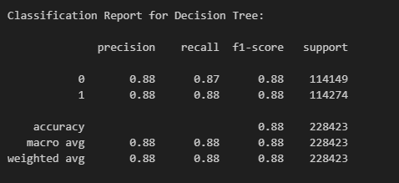
Figure: Classification Report for DT
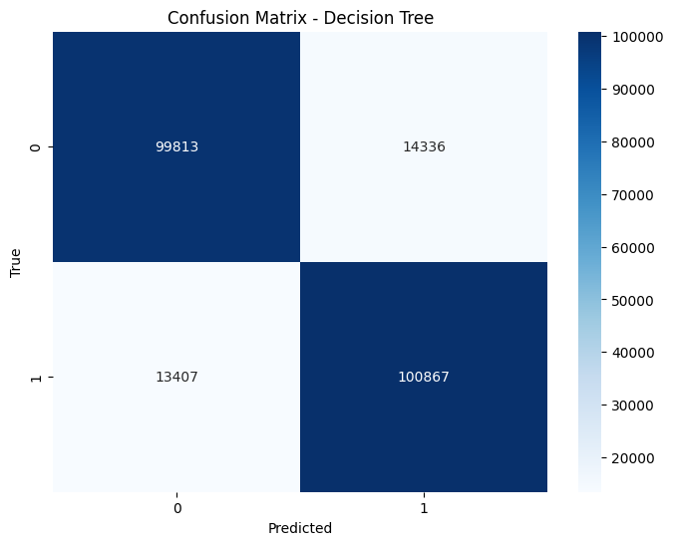
Figure: Confusion Matrix for DT
Random Forest
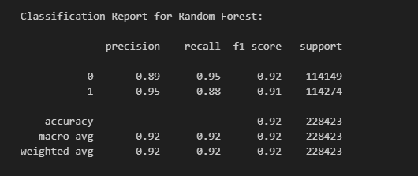
Figure: Classification Report for RF
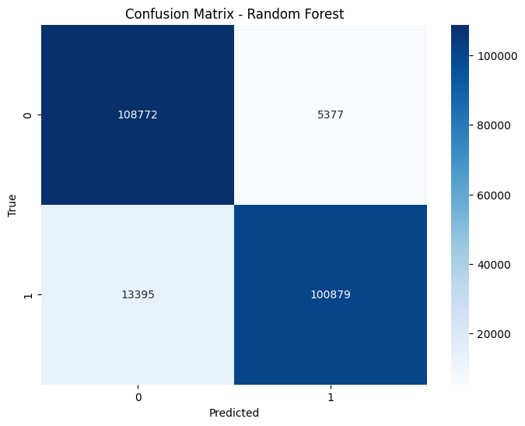
Figure: Confusion Matrix for RF

Gradient Boosting
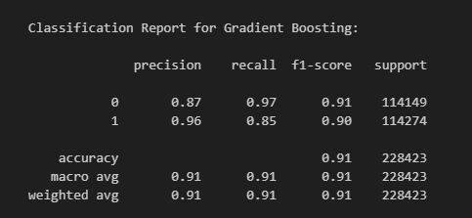
Figure: Classification Report for GB
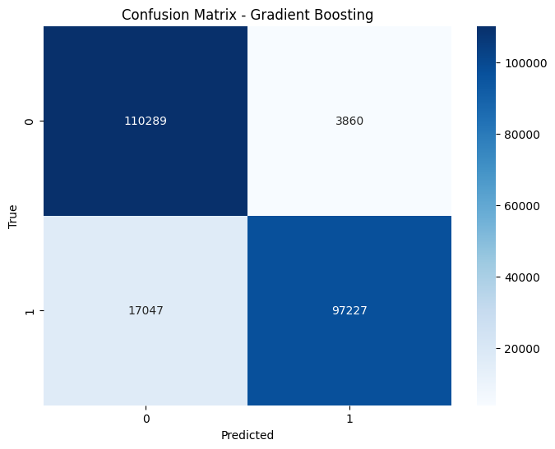
Figure: Confusion Matrix for GB
LightGBM
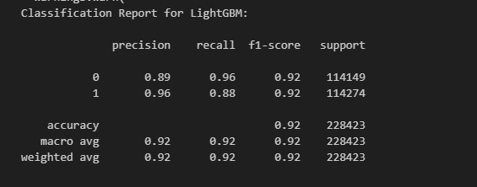
Figure: Classification Report for LightGBM
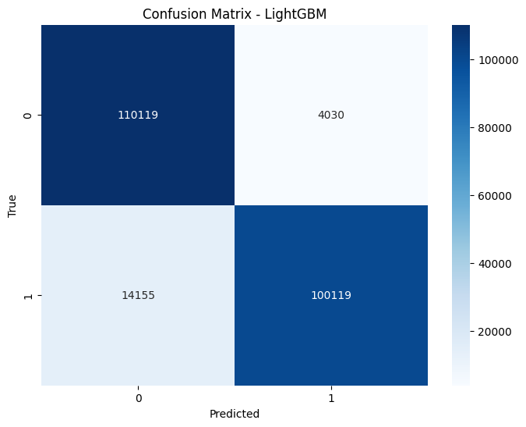
Figure: Confusion Matrix for LightGBM
RNN
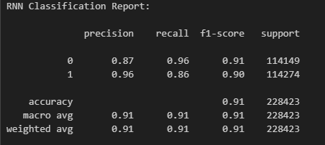

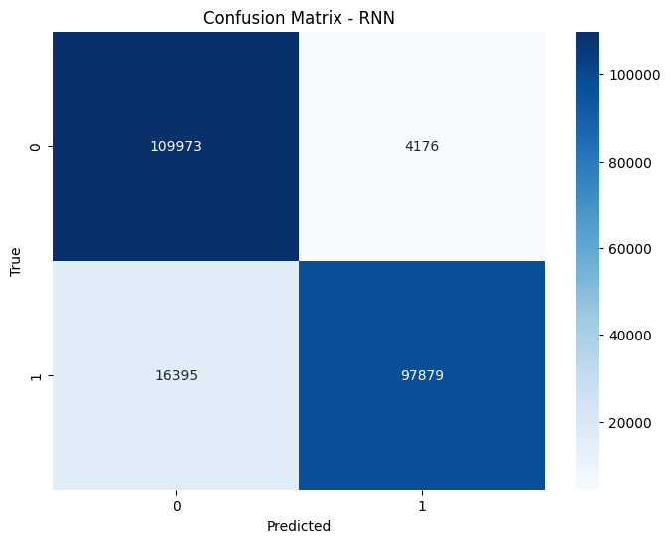
Stacking Classifier
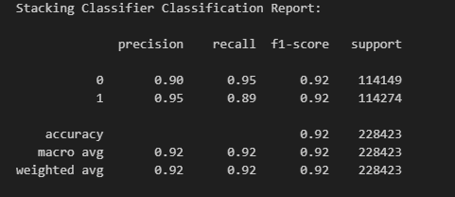

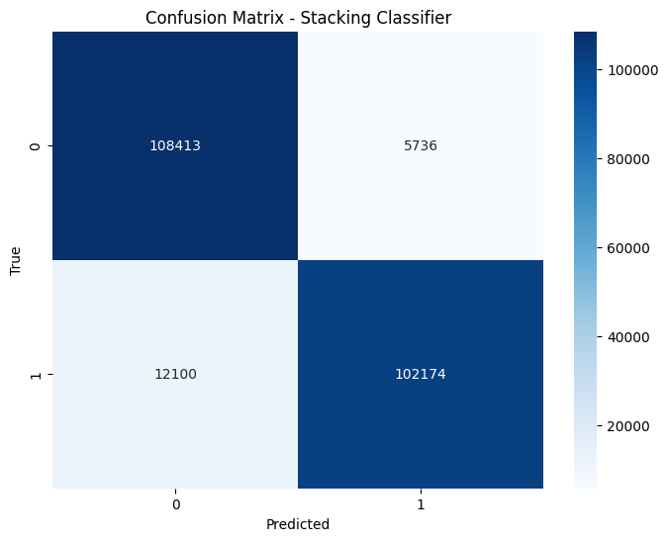
LSTM Classifier
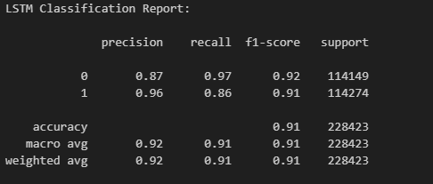
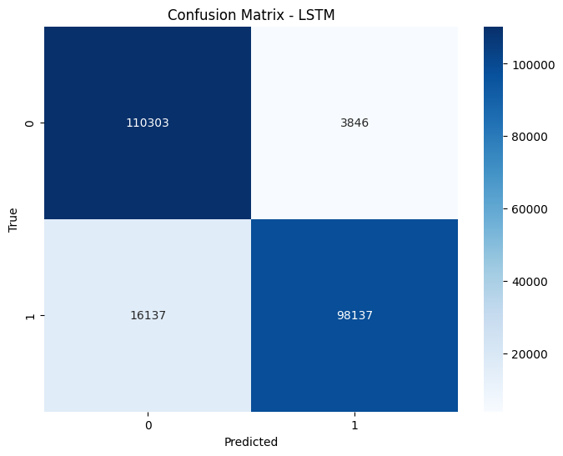
GRU Classifier
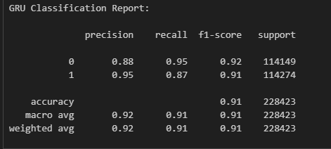
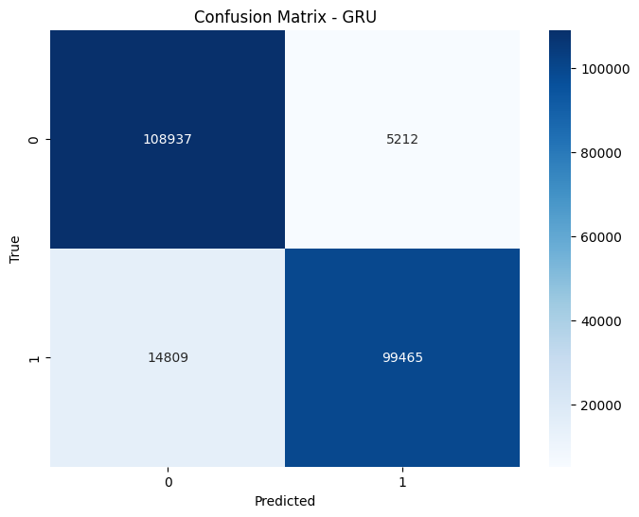
Model Comparison
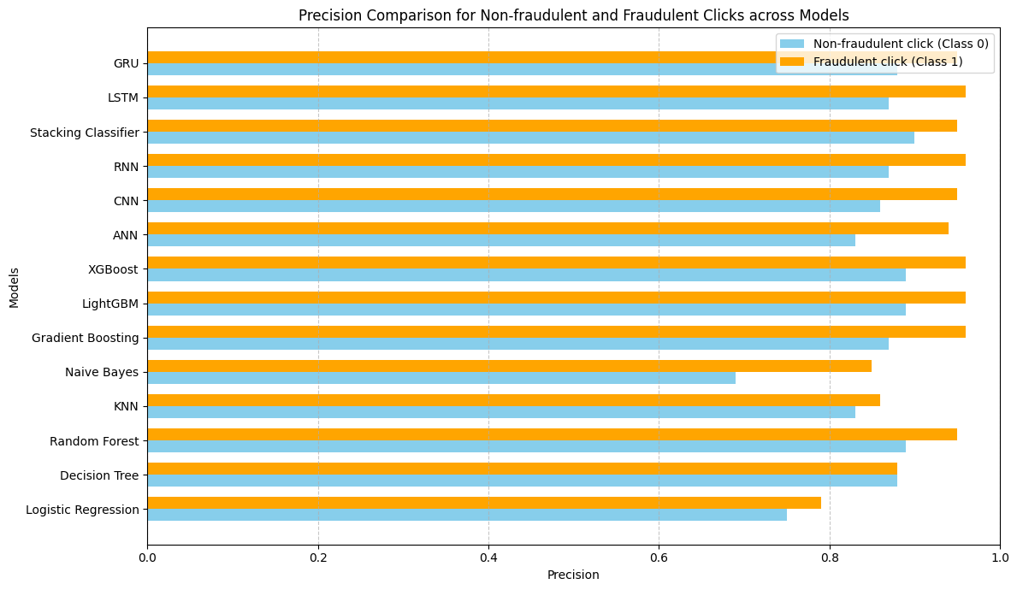

The precision analysis across multiple models for ad click fraud detection reveals significant performance differences. GRU and LSTM, both recurrent neural network architectures, demonstrate the highest precision, especially for detecting fraudulent clicks (Class 1), indicating their superior ability to capture sequential patterns in clickstream data. Their effectiveness in modeling temporal dependencies makes them highly suitable for fraud scenarios where timing and sequence matter. The Stacking Classifier, which combines outputs from models like Decision Tree, Random Forest, LightGBM, XGBoost, and Logistic Regression, also shows excellent precision for both classes, leveraging ensemble learning to generalize better and reduce individual model biases. Classical boosting models—XGBoost, LightGBM, and Gradient Boosting—achieve strong precision, particularly for Class 1, with scores consistently exceeding 0.90. These models are robust against class imbalance and excel in feature-rich environments. Random Forest and Decision Tree maintain competitive precision, though slightly lower than boosting models, with Random Forest performing better due to its aggregation of multiple trees. Deep learning architectures like CNN, ANN, and RNN offer good Class 1 precision, suggesting they are capable of learning complex non-linear patterns. However, their performance for Class 0 is slightly lower, potentially due to a tendency to overfit to fraudulent class samples. KNN performs reasonably well but is affected by high-dimensionality and computational inefficiency, making it less suitable for large-scale real-time predictions. Naive Bayes, due to its assumption of feature independence, shows lower precision, especially for Class 1, making it unsuitable for nuanced fraud detection. Similarly, Logistic Regression, while interpretable and fast, has the weakest precision overall, highlighting its limitations in capturing complex interactions in imbalanced data. In conclusion, the evaluation illustrates that temporal models and ensemble learners significantly outperform simpler classifiers, offering more accurate and trustworthy predictions for both fraudulent and non-fraudulent ad clicks.

10. CONCLUSION:
The Ad Click Fraud Detection System developed in this project demonstrates the powerful application of machine learning and deep learning techniques in identifying fraudulent ad clicks with high accuracy. By leveraging models such as Logistic Regression, Random Forest, XGBoost, LightGBM, CNN, LSTM, GRU, and ensemble stacking, the system effectively distinguishes between legitimate and fake clicks in real time. The integration of a Flask-based web interface ensures usability, making it accessible to advertisers and analysts for practical deployment. With robust input validation, real-time prediction, and confidence scoring, the platform enhances ad campaign transparency and return on investment. Furthermore, the project emphasizes efficiency by using open-source tools, resulting in a cost-effective and scalable solution. The system achieves its core objectives of fraud minimization, accuracy, and ease of use. Overall, the solution proves to be a reliable decision-support tool in digital marketing environments, helping stakeholders mitigate losses and optimize performance by preemptively filtering fraudulent activity.

.
11. FUTURE ENHANCEMENT
To further enhance the system's effectiveness and scalability, several improvements can be implemented in future iterations. Firstly, integrating explainable AI (XAI) techniques such as SHAP and LIME can provide users with deeper insights into why a particular click is classified as fraudulent, increasing trust in the system. Secondly, adding real-time integration with advertising platforms via APIs can automate fraud detection and flagging during live campaigns. Support for unsupervised anomaly detection algorithms would allow identification of previously unseen fraud patterns. Additionally, implementing adaptive learning would enable the system to continuously improve its accuracy as new data is collected. Multi-language support and advanced dashboard analytics can enhance usability for global stakeholders. Finally, deploying the system as a SaaS product on cloud platforms with load balancing and auto-scaling features would make it suitable for enterprise-level adoption. These enhancements will ensure that the system remains robust, adaptive, and industry-relevant in the evolving landscape of digital advertising fraud.

12. REFERENCES:

- Alzahrani, R., Aljabri, M., & Mohammad, R. M. A. (2025). Ad Click Fraud Detection Using Machine Learning and Deep Learning Algorithms. IEEE Access. https://doi.org/10.1109/ACCESS.2025.3532200
- Aljabri, M., & Mohammad, R. M. A. (2023). Click Fraud Detection for Online Advertising Using Machine Learning. Egyptian Informatics Journal, 24(3), 241–252. https://doi.org/10.1016/j.eij.2023.05.006
- Batool, A., & Byun, Y. (2022). An Ensemble Architecture Based on Deep Learning Model for Click Fraud Detection in Pay-Per-Click Advertisement Campaign. IEEE Access, 10, 99234–99249. https://doi.org/10.1109/ACCESS.2022.3211528
- Kirkwood, B., Vanamala, M., & Seliya, N. (2024). Click Fraud Detection of Online Advertising Using Machine Learning Algorithms. Proceedings of the IEEE International Conference on Electro Information Technology (EIT).
- Yu, Q., Tang, X., Li, F., & Cao, Z. (2024). Improved Adaboost Algorithm for Web Advertisement Click Prediction Based on Long Short-Term Memory Networks. arXiv preprint, arXiv:2408.05245. https://arxiv.org/abs/2408.05245
- Purwar, A., Jain, A., Chawla, I., & Jain, D. (2024). Click Fraud Detection Using Ensemble Classifier. In Advances in Artificial-Business Analytics and Quantum Machine Learning (pp. 145–159). Springer.
- Miotto, R., Wang, F., Wang, S., Jiang, X., & Dudley, J. T. (2018). Deep learning for healthcare: review, opportunities and challenges. Briefings in Bioinformatics, 19(6), 1236–1246.
- He, K., Zhang, X., Ren, S., & Sun, J. (2016). Deep Residual Learning for Image Recognition. Proceedings of the IEEE Conference on Computer Vision and Pattern Recognition (CVPR), 770–778.
- Howard, A. G., Zhu, M., Chen, B., Kalenichenko, D., Wang, W., Weyand, T., ... & Adam, H. (2017). MobileNets: Efficient Convolutional Neural Networks for Mobile Vision Applications. arXiv preprint, arXiv:1704.04861.
- Litjens, G., Kooi, T., Bejnordi, B. E., Setio, A. A. A., Ciompi, F., Ghafoorian, M., ... & van Ginneken, B. (2017). A Survey on Deep Learning in Medical Image Analysis. Medical Image Analysis, 42, 60–88.

